Report

Laboratory Work 7

Dmitry Ladutsko

July 22, 2022

# Prerequisites

## 1.1. Passwords Index

|  |  |  |
| --- | --- | --- |
| Password Group | Login Name | Password |
| Operation System | root | “rootadmin” |
|  | oracle | “oracleadmin” |
|  |  |  |
| Oracle System | sys | “sysadmin” |
|  | system | “sysadmin” |
|  |  |  |
| Oracle Users | All DB users | “%PWD%” |
|  |  |  |
|  |  |  |

## 1.2. Folder Paths Index

|  |  |  |
| --- | --- | --- |
| Path Group | Path Description | Path |
| Operation System | Oracle RDBMS – BIN | /oracle/app/oracle |
|  | Oracle Inventory | /oracle/app/oraInventory |
|  | Oracle Database Storage | /oracle/oradata |
|  | Oracle Install Directory | /oracle/install |
| Oracle | ORACLE_BASE | /oracle/app/oracle |
|  | ORACLE_HOME | $ORACLE_BASE/product/11.2 |
|  |  |  |
| FTP | ftp Incoming Folder | **/ftp/incoming** |
|  |  |  |
|  |  |  |

# 

# 2. Create and populate Dimension of TIME DW – Layer

**Notes:**

To Populate Time dims use External Resources:

|  |  |
| --- | --- |
| File Name | Path |
| Calendars.sql | … \Topic 07 - Dimension and Facts Basics\LabScripts\ |

## 2.1. Task 01: CREATE DW.T_DAYS

**The Main Task** is to create Physical diagram and Objects on DW layer:

**Task Results:**

Create document, which contained next chapters:

* Physical diagram store on GIT
* Links to Scripts on GIT

## 2.2. Task 02: CREATE DW.T_WEEKS

**The Main Task** is to create Physical diagram and Objects on DW layer:

**Task Results:**

Create document, which contained next chapters:

* Physical diagram store on GIT
* Links to Scripts on GIT

## 2.3. Task 03: CREATE DW.T_MONTHS

**The Main Task** is to create Physical diagram and Objects on DW layer:

**Task Results:**

Create document, which contained next chapters:

* Physical diagram store on GIT
* Links to Scripts on GIT

## 2.4. Task 04: CREATE DW.T_QUARTERS

**The Main Task** is to create Physical diagram and Objects on DW layer:

**Task Results:**

Create document, which contained next chapters:

* Physical diagram store on GIT
* Links to Scripts on GIT

## 2.5. Task 05: CREATE DW.T_YEARS

**The Main Task** is to create Physical diagram and Objects on DW layer:

**Task Results:**

Create document, which contained next chapters:

* Physical diagram store on GIT
* Links to Scripts on GIT

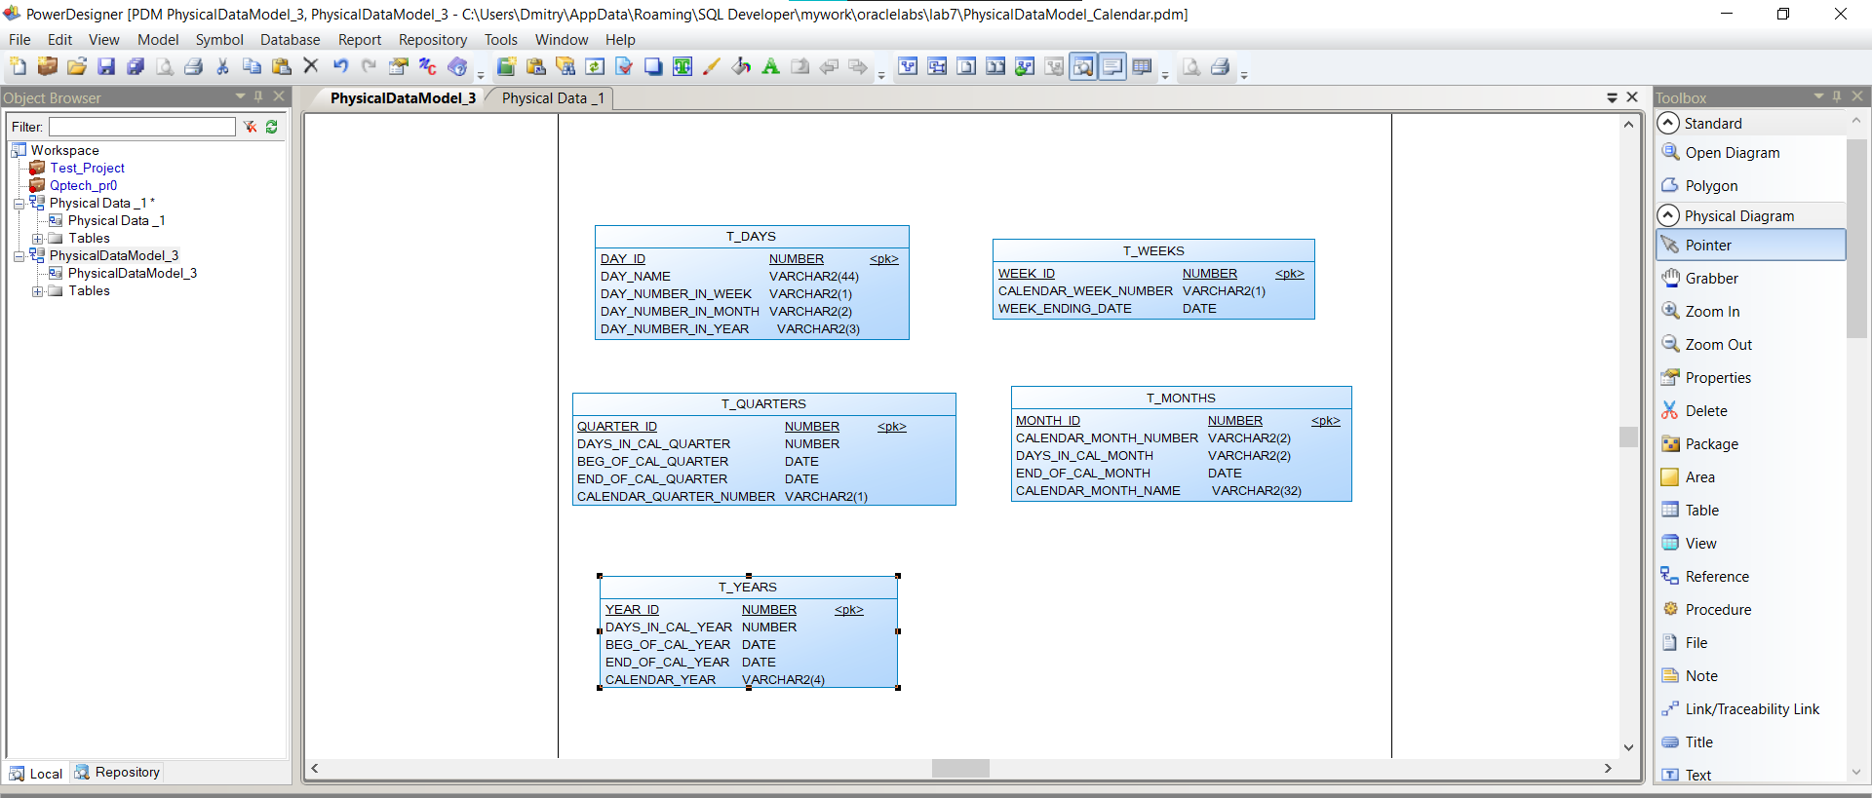

**Laboratory work summary:**

At this laboratory work, we touched principals of (re)building schemas, used our knowledge in practice and saw how DFD and physical diagrams can help in understanding of schema building.

We created Calendar at first; then we created impl and def packages to insert cleansing tables.

After cleansing, we created tables for each dimension: day, week, month, quarter, and year. We added primary column for them and created sequences, views. We created init script files to insert with data each from their cleansed “brothers”. At screenshots below, you can see the structure of tables and data they store.

All diagrams and scripts are stored in GitHub (link in README file in Labs folder)

